Dear Family and Friends, November 2016
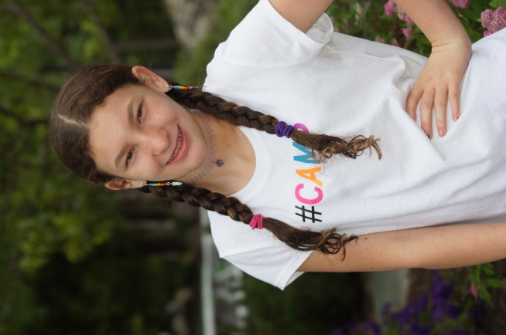
Season’s Greetings! 2016 was another exciting year for the Griggs family. It was full of adventures, vacations, changes, and decisions. One of the most important decisions Ben and I made was to be more proactive about Fanconi anemia research, so when we were invited to join the Fanconi Anemia Research Fund’s Philanthropy Council, we gladly accepted the invitation! If you walk up to any stranger on the street and ask them what Fanconi anemia (FA) is, chances are, they won’t have a clue. For us, that’s a big problem. We had not heard of FA either until 2010, when Bella was given this rare, life long, terminal diagnosis at the young age of age of 6.
FA is an ‘orphan disease’ and unfortunately, nobody wants to adopt it. It is so rare that pharmaceutical industries find little financial incentive to research new treatments or medications to help kids like Bella. Because of the orphan status, it is up to us, the family and friends of those affected by FA, to lead the charge into battle against this horrible disease. We call these people, including you, our “FA-mily” – the people we know we can depend on for support when we need help.
FAmily, Bella needs your help.
As you may already know, Fanconi anemia is an inherited disease that can lead to bone marrow failure and cancer. Though considered primarily a blood disease, FA may affect all systems of the body. For Bella, it has affected her digestive system, heart, metabolic system, hearing, and other areas. It is a complex and chronic disorder that is physically and psychologically demanding. FA is also a cancer prone disease, affecting patients decades earlier than the general population. The median life span for someone with Fanconi anemia is just 33 years.
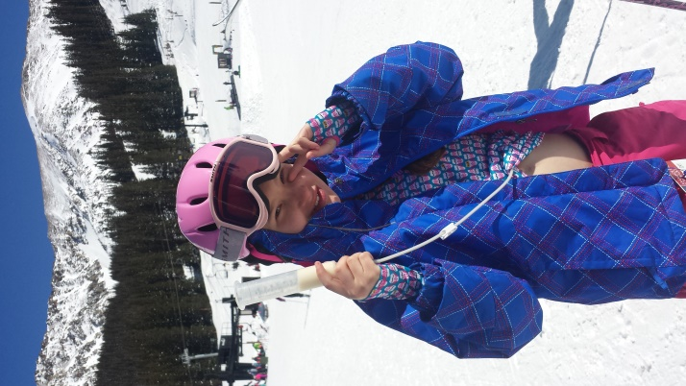
Bella, now 12 years old, has had an incredible year despite a few medical setbacks. She learned how to ski AND snowboard last winter, and is looking forward to hitting the slopes again in a few weeks. She is in 6th grade at Academy Charter School in Castle Rock, Colorado. She absolutely loves her new school and her teacher, Mrs. Owen. With a strong educational plan and wonderful staff support, Bella has been making great strides in school despite missing several hours of instruction each week due to multiple doctor and therapy appointments. This fall, Bella joined the ACS Eagles Volleyball team. She struggles to keep up with her teammates, but enjoys the camaraderie. She is also a cheerleader for her school’s basketball team. Go Eagles!
Unfortunately, because of Fanconi anemia, Bella’s bone marrow continues to fail. This year, her ANC (absolute neutrophil count) and cellularity (measures of bone marrow function) hit an all-time low, and her platelets have continued to drop to dangerous levels. It is only a matter of time before she needs a bone marrow transplant. The transplant will wipe out her existing sick bone marrow, bringing her to the edge of death before replacing it with life-saving new bone marrow. 25 years ago, Bella’s chance of surviving transplant was 0%. Not survivable. But thanks to FAmily funded research and support, the chances of her surviving a transplant today are 87%. We cannot rest until this number has reached 100%.
In 2016, FAmilies contributed nearly $2 million to fund family services and scientific research, of which $1.9 million was used to fund new research grants. These research grants give us hope that one day Bella will defy the odds stacked against her. Research is the only way we can find new and better treatments for Fanconi anemia, as well as increase transplant survivability. We need your help to make this happen.
Please consider a gift to the Fanconi Anemia Research Fund (FARF) in Bella’s honor during this holiday season. We won’t be able to wrap it up and place it under the Christmas tree, but this gift would be better than anything you could fit in a box. A donation to FARF will give us hope that Bella might one day be cured of this horrible disease. With your help, we will be more optimistic about her future and survivability when she needs a bone marrow transplant. Your donation is the gift of time that will help us create a lifetime of memories with our daughter, and for that, we cannot thank you enough! We wish you and your family the happiest of holidays and infinite blessings in the New Year.
With Love and Gratitude,
The Griggs Family
Ben & Stephanie, Adrianna, Kennedy, and Isabella Claire
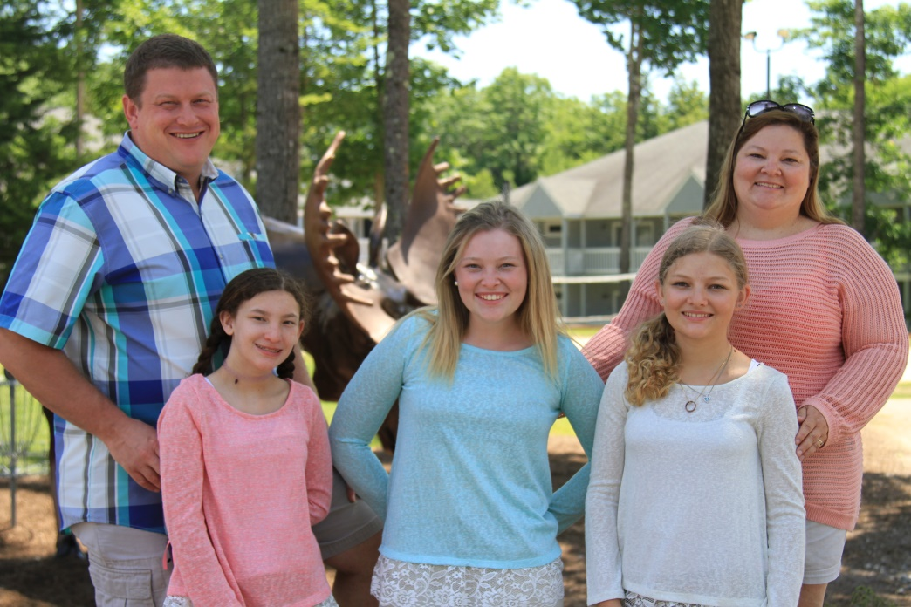
Enclosed is an addressed contribution envelope to help you conveniently make your donation. All donations, no matter how big or small, are greatly appreciated and make an impact. Please make your check payable to the Fanconi Anemia Research Fund. If you prefer to make a donation online, please visit Fanconi.org and click on the red heart in the upper right corner. Be sure to tell them Bella sent you! Your donation is 100% tax deductible and a receipt will be sent to you by FARF for your records. Thank you so much for your support!

